|  |
| --- |
| Class-btn |
| Btn() |
|  |

|  |
| --- |
| Class-clock |
| Clock()  int time |
| void decrease() |

|  |
| --- |
| Class-drum |
| Drum()  計算時間  int x_speed |
| void setSpeed(int speed)  void *advance*(int phase) |

|  |
| --- |
| Class-point |
| Point() |
|  |

產生物件

|  |
| --- |
| Class-score |
| Score()  int score |
| void increase() |

計算分數

|  |
| --- |
| Class-scene |
| Scene();  Btn *btn_start  Btn *btn_close;  Btn *btn_change_ball;  Btn *btn_pause;  Btn *btn_conti;  Btn *btn_back;  Point *pt;  int btn_w;  int btn_h;  int btn_small_w;  int btn_small_h;  int pt_w;  int pt_h;  QList<Drum *> drum_list;  QList<int> rand_list;  Clock *clo;  int clo_time;  Score *sco;  int ch_y_pos;  QSound *bgm;  QTimer *timer;  int screenMode;  int upperBound;  int lowerBound;  int leftBound;  int rightBound; |
| void Init(int x_start )  void bgChange()  void bgRecover()  void gameInit()  void movingBlock()  void *mousePressEvent*(QGraphicsSceneMouseEvent *mouse)  void *keyPressEvent*(QKeyEvent *event)  void geneDrum()  void bgclose()  執行遊戲 |

|  |
| --- |
| Class-maiwidow |
| explicit MainWindow(QWidget *parent = 0)  ~*MainWindow*()  Scene *scene  調整視窗  Ui::MainWindow *ui |
| void settingBg(int x_start , int y_end) |

|  |
| --- |
| main.cpp |
|  |
|  |

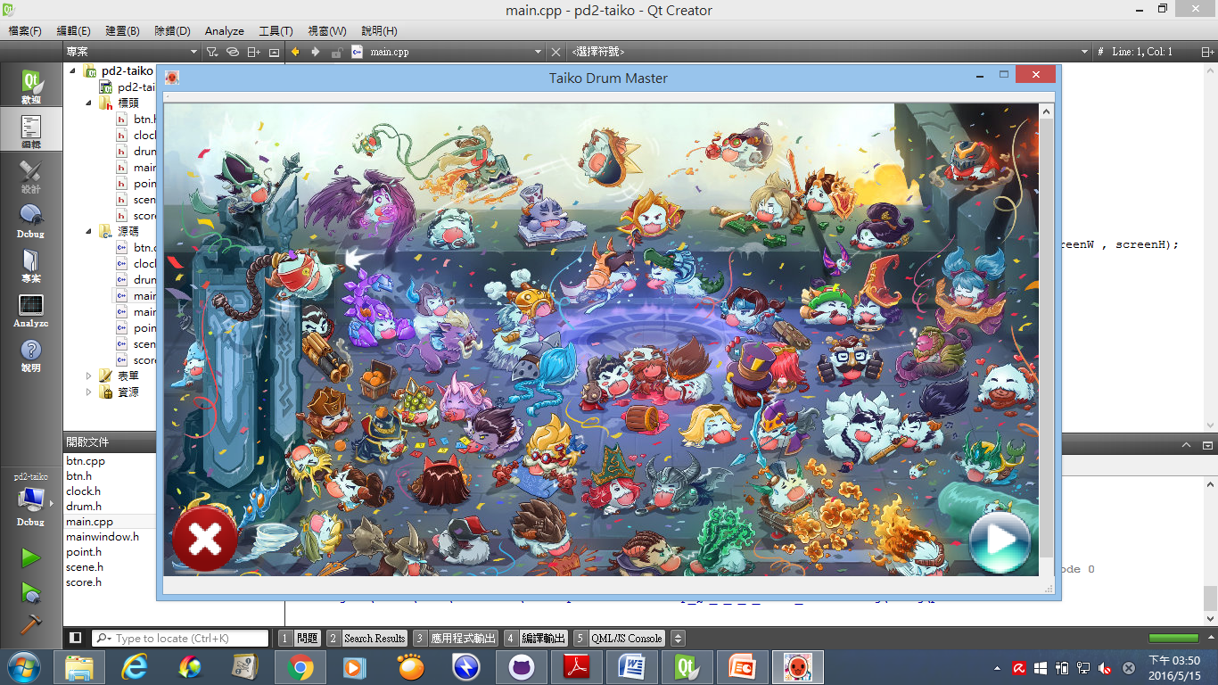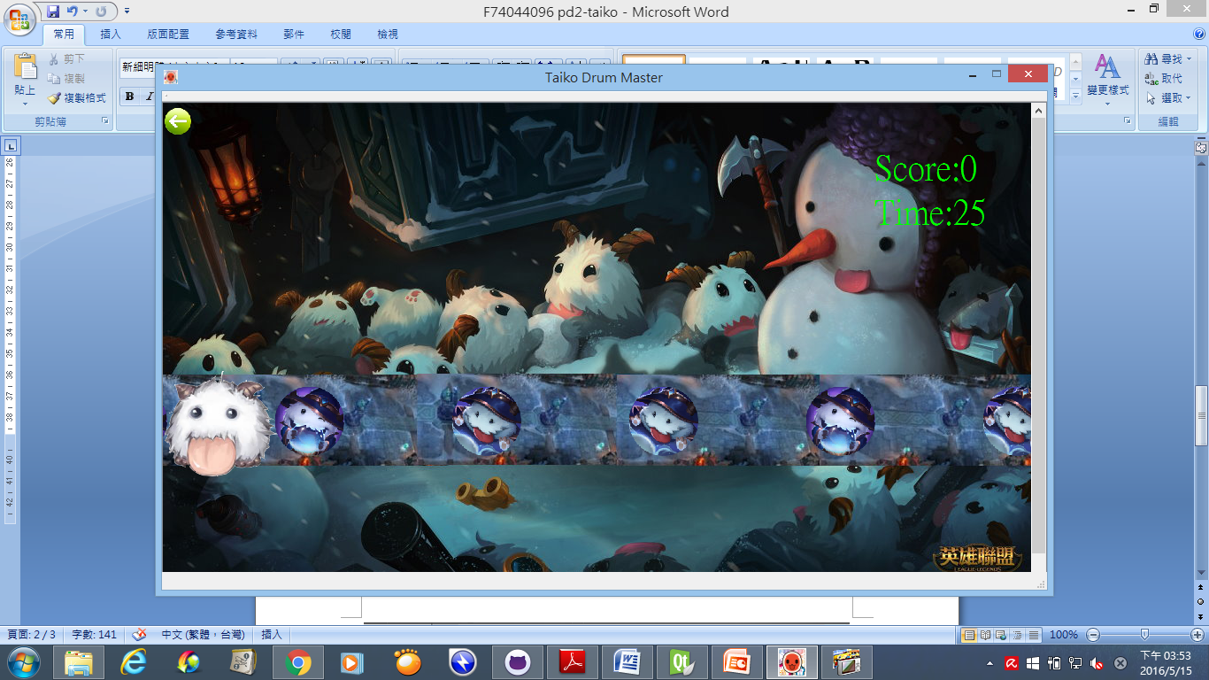

重新開始遊戲

用滑鼠按一下，開始玩

消除點，鼓到這裡便可按按鍵來做消除

用K鍵來消除

用J鍵來消除